# Lab: Generics

Problems for exercises and homework for the ["Java OOP Advanced" course @ SoftUni](https://softuni.bg/trainings/2246/java-advanced-january-2019).

You can check your solutions here: <https://judge.softuni.bg/Contests/1526> .

# Part I: Generics

## Jar of T

Create a class **Jar<>** that can store **anything**.

It should have two public methods:

* void add(element)
* element remove()

Adding should add on **top** of its contents. Remove should get the **topmost** element.

### Examples

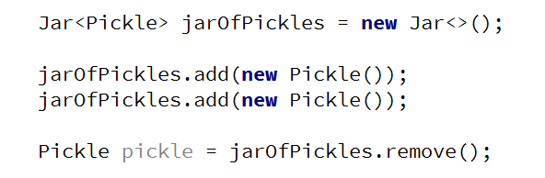

### Hints

Use the syntax Jar<T> to create a generic class

## Generic Array Creator

Create a class ArrayCreator with a method and a single overload to it:

* static T[] create(int length, T item)
* static T[] create(Class<T> class, int length, T item)

The method should return an array with the given length and every element should be set to the given default item.

### Examples

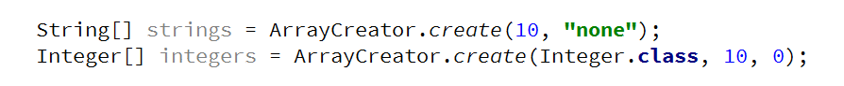

## Generic Scale

Create a class **Scale<T>** that holds two elements - left and right. The scale should receive the elements through its single constructor:

* Scale(T left, T right)

The scale should have a single method:

* T getHeavier()

The greater of the two elements is heavier. The method should return null if elements are equal.

### Examples

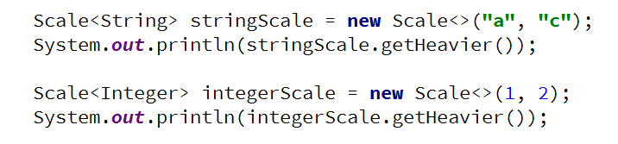

## List Utilities

Create a class ListUtils that you will use through several other exercises:

The class should have two static methods:

* T getMin(List<T> list)
* T getMax(List<T> list)

The methods should throw IllegalArgumentException if an empty list is passed.

### Examples

